Python:

sentence=input("Enter a sentence: ")

sentence=list(sentence)

l, d = 0, 0

for i in sentence:

if i.isalpha():

l = l + 1

if i.isdigit():

d = d + 1

print("LETTERS: ",l)

print("DIGITS: ",d)

Output:

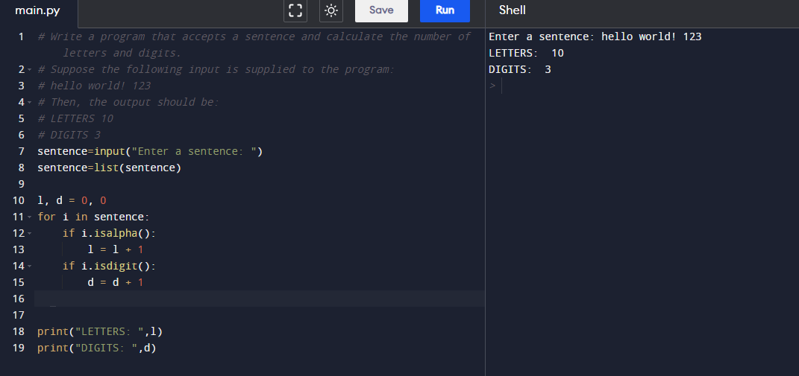

C-programming:

#include <stdio.h>

#include <ctype.h>

void count_letters_digits(const char *sentence, int *l, int *d) {

*l = 0;

*d = 0;

for (int i = 0; sentence[i] != '\0'; i++) {

if (isalpha(sentence[i])) {

(*l)++;

} else if (isdigit(sentence[i])) {

(*d)++;

}

}

}

int main() {

char input_sentence[100];

int l, d;

printf("Enter a sentence: ");

fgets(input_sentence, sizeof(input_sentence), stdin);

count_letters_digits(input_sentence, &l, &d);

printf("LETTERS %d\n", l);

printf("DIGITS %d\n", d);

return 0;

}

Output:

